Test Case: tc002_SPX_Dev5_Crear_Requisicion_Spot_Con_FAD_Tipo_Cobro_CC
Step 1 - Enter username and password and click to button Enter : Credentials Entered
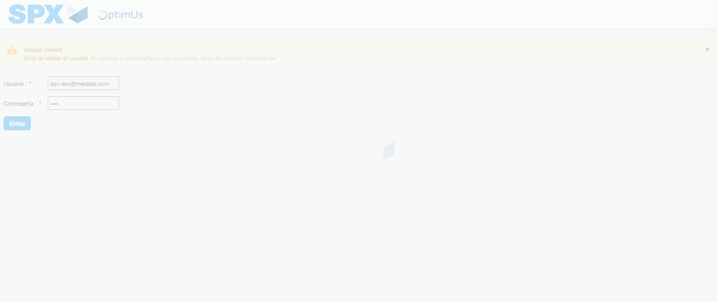Image file-name: QC_Testing-tc002_SPX_Dev5_Crear_Requisicion_Spot_Con_FAD_Tipo_Cobro_CC-1789485038740

Step 2 - Select to UEN and Access to Spot Buy Requisitions : UEN Correctly selected and Correct access
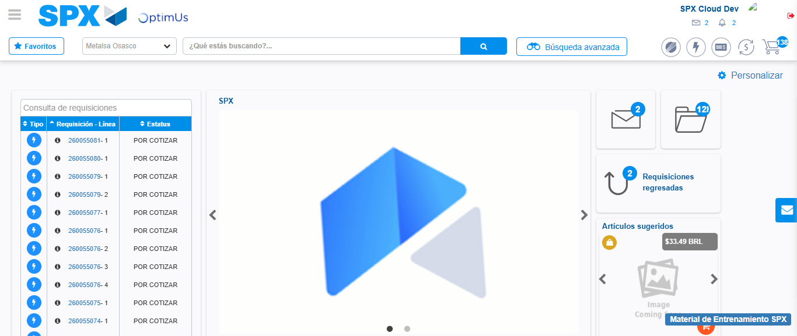Image file-name: QC_Testing-tc002_SPX_Dev5_Crear_Requisicion_Spot_Con_FAD_Tipo_Cobro_CC-1789485062456

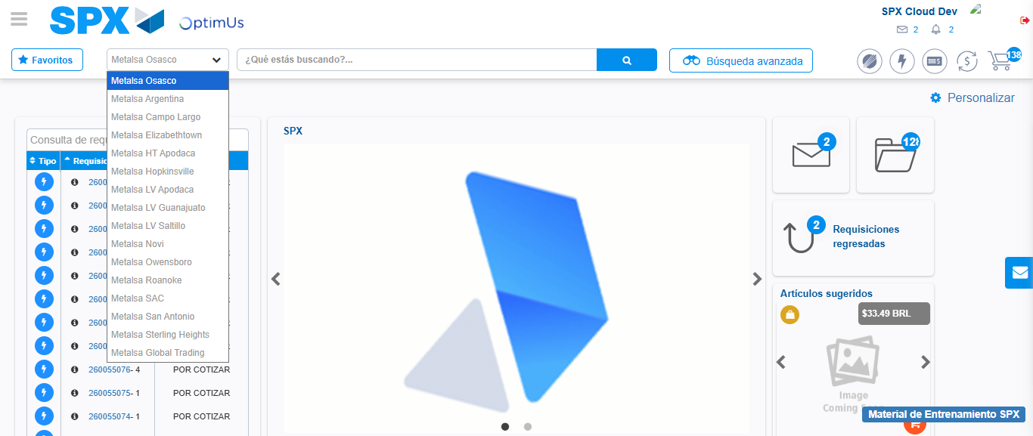Image file-name: QC_Testing-tc002_SPX_Dev5_Crear_Requisicion_Spot_Con_FAD_Tipo_Cobro_CC-1789485063144

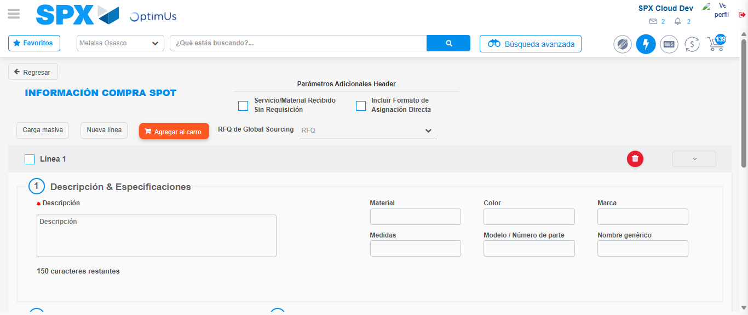Image file-name: QC_Testing-tc002_SPX_Dev5_Crear_Requisicion_Spot_Con_FAD_Tipo_Cobro_CC-1789485074724

Step 3 - Add FAD to Requisition: FAD Successfully Added
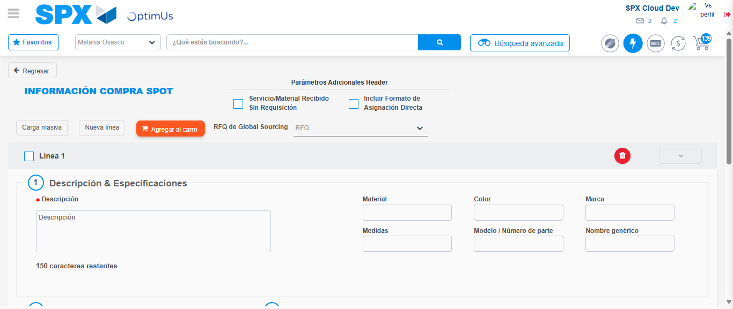Image file-name: QC_Testing-tc002_SPX_Dev5_Crear_Requisicion_Spot_Con_FAD_Tipo_Cobro_CC-1789485075000

Image file-name: QC_Testing-tc002_SPX_Dev5_Crear_Requisicion_Spot_Con_FAD_Tipo_Cobro_CC-1789485075193

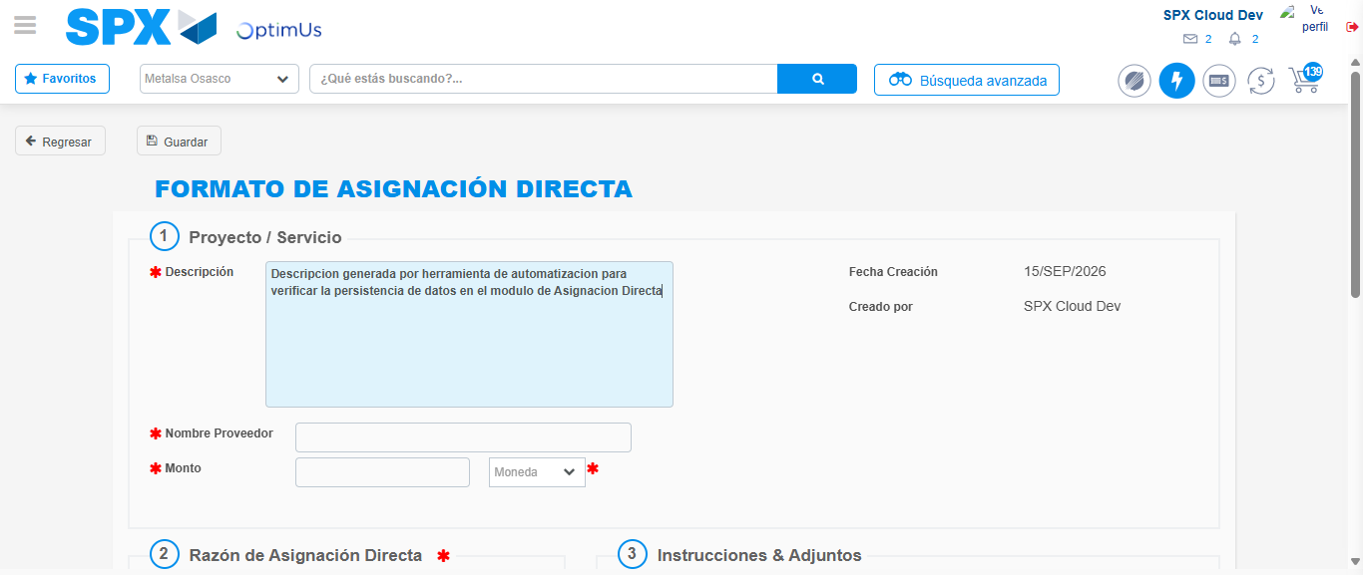Image file-name: QC_Testing-tc002_SPX_Dev5_Crear_Requisicion_Spot_Con_FAD_Tipo_Cobro_CC-1789485078063

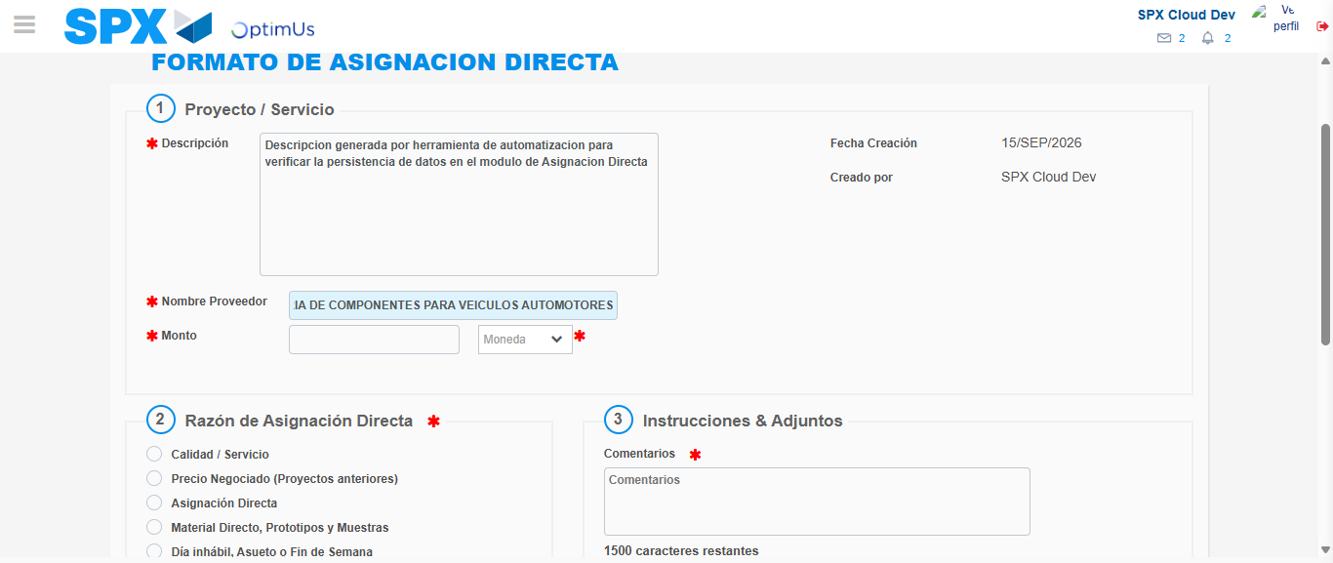Image file-name: QC_Testing-tc002_SPX_Dev5_Crear_Requisicion_Spot_Con_FAD_Tipo_Cobro_CC-1789485087757

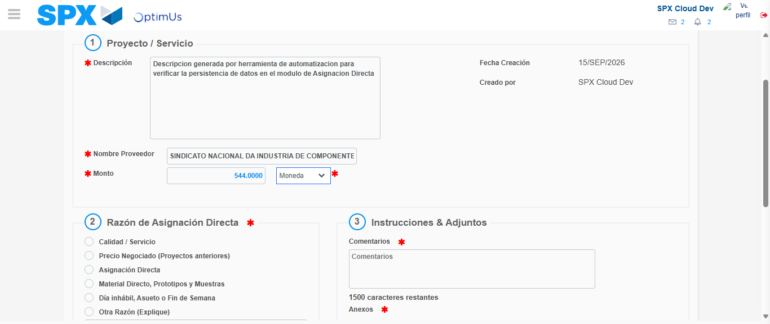Image file-name: QC_Testing-tc002_SPX_Dev5_Crear_Requisicion_Spot_Con_FAD_Tipo_Cobro_CC-1789485088183

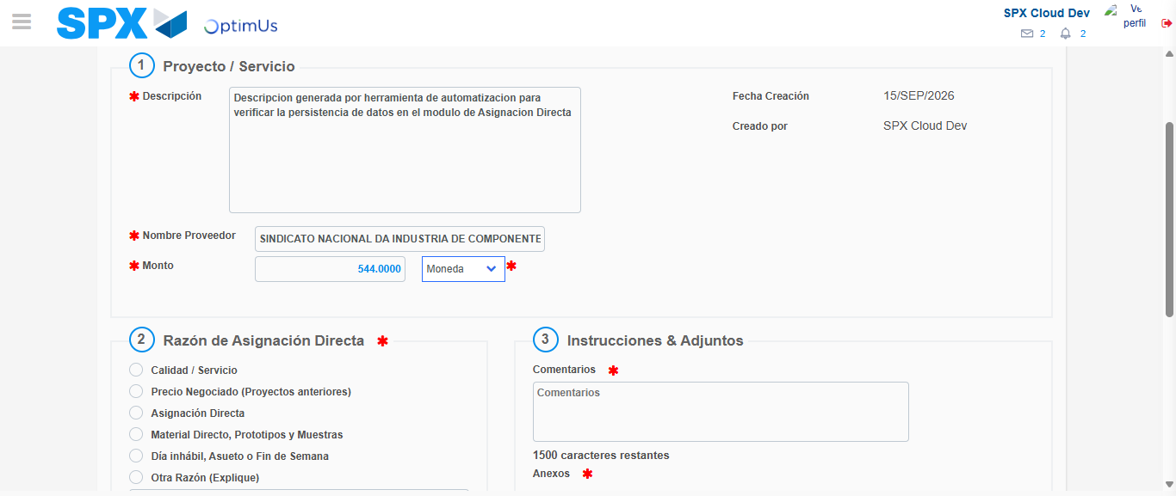Image file-name: QC_Testing-tc002_SPX_Dev5_Crear_Requisicion_Spot_Con_FAD_Tipo_Cobro_CC-1789485088424

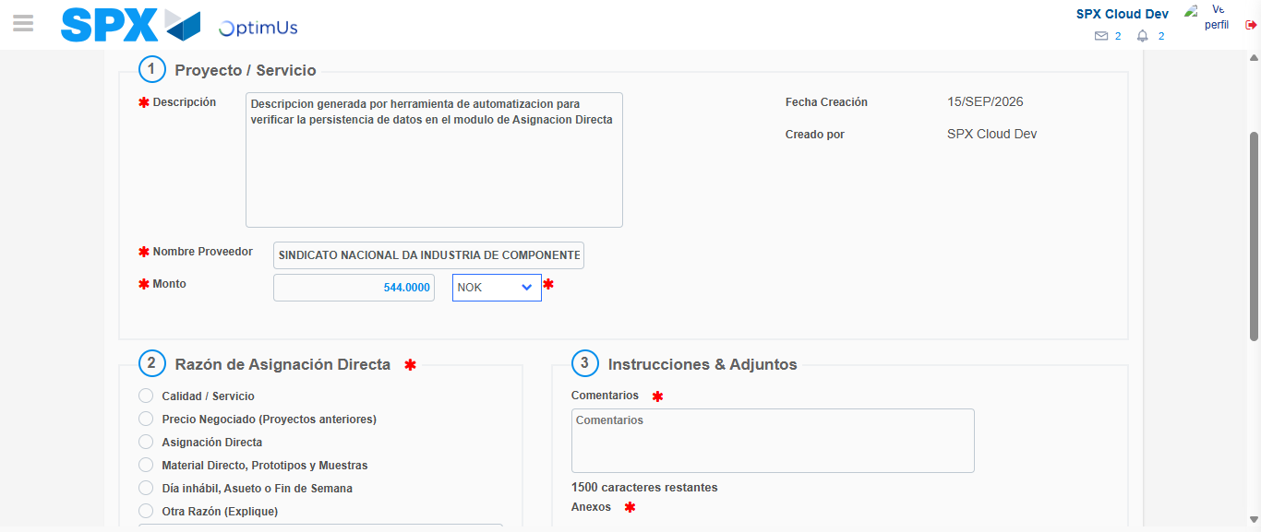Image file-name: QC_Testing-tc002_SPX_Dev5_Crear_Requisicion_Spot_Con_FAD_Tipo_Cobro_CC-1789485088854

Image file-name: QC_Testing-tc002_SPX_Dev5_Crear_Requisicion_Spot_Con_FAD_Tipo_Cobro_CC-1789485089071

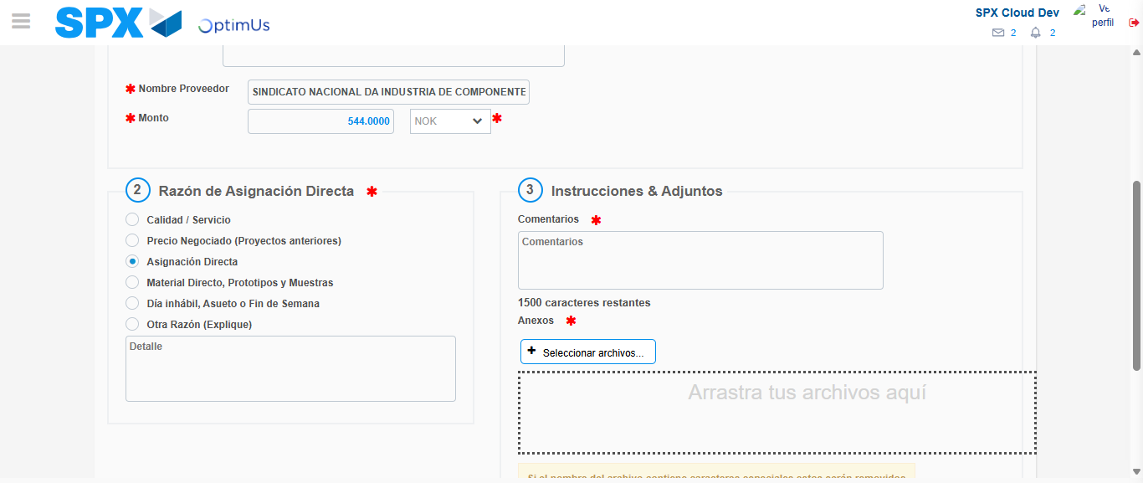Image file-name: QC_Testing-tc002_SPX_Dev5_Crear_Requisicion_Spot_Con_FAD_Tipo_Cobro_CC-1789485090009

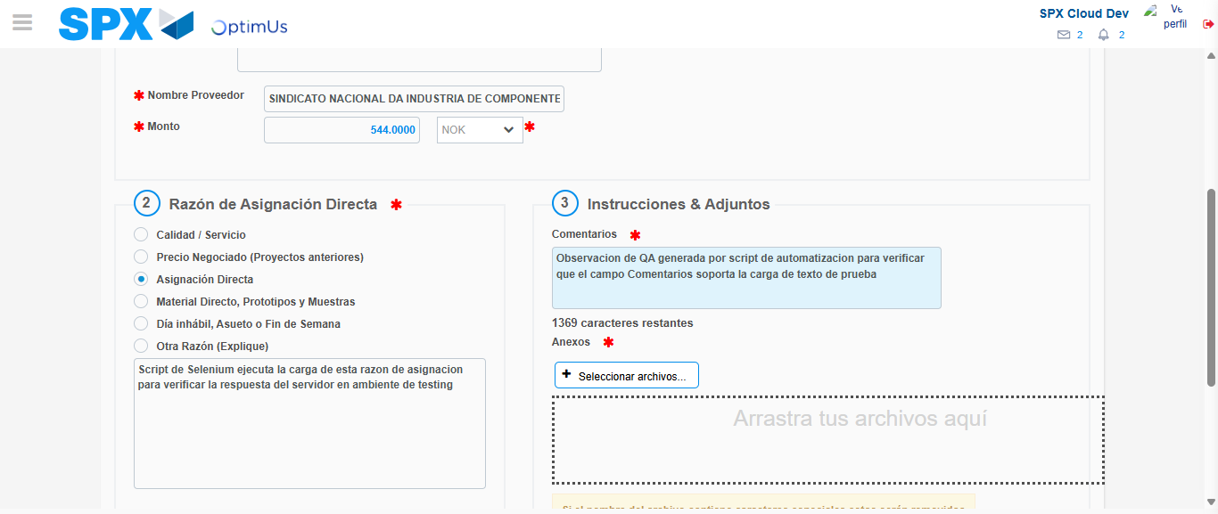Image file-name: QC_Testing-tc002_SPX_Dev5_Crear_Requisicion_Spot_Con_FAD_Tipo_Cobro_CC-1789485101308

Image file-name: QC_Testing-tc002_SPX_Dev5_Crear_Requisicion_Spot_Con_FAD_Tipo_Cobro_CC-1789485102024

Step 4 - Data Capture Spot Buy Requisition: Data captured correctly
Image file-name: QC_Testing-tc002_SPX_Dev5_Crear_Requisicion_Spot_Con_FAD_Tipo_Cobro_CC-1789485075000

Image file-name: QC_Testing-tc002_SPX_Dev5_Crear_Requisicion_Spot_Con_FAD_Tipo_Cobro_CC-1789485075193

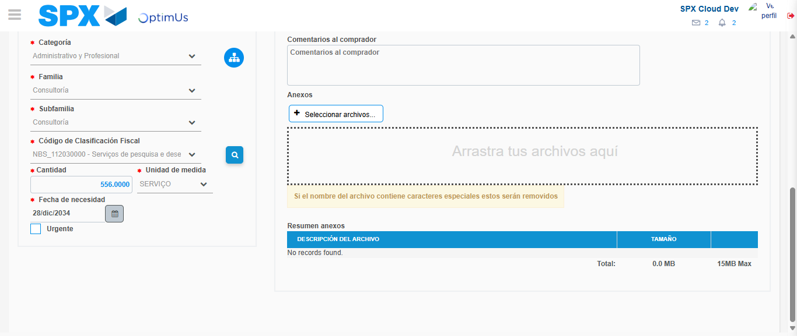Image file-name: QC_Testing-tc002_SPX_Dev5_Crear_Requisicion_Spot_Con_FAD_Tipo_Cobro_CC-1789485120109

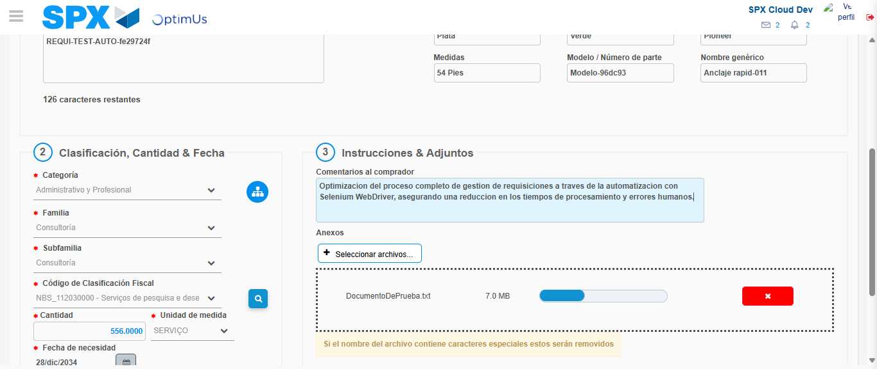Image file-name: QC_Testing-tc002_SPX_Dev5_Crear_Requisicion_Spot_Con_FAD_Tipo_Cobro_CC-1789485121084

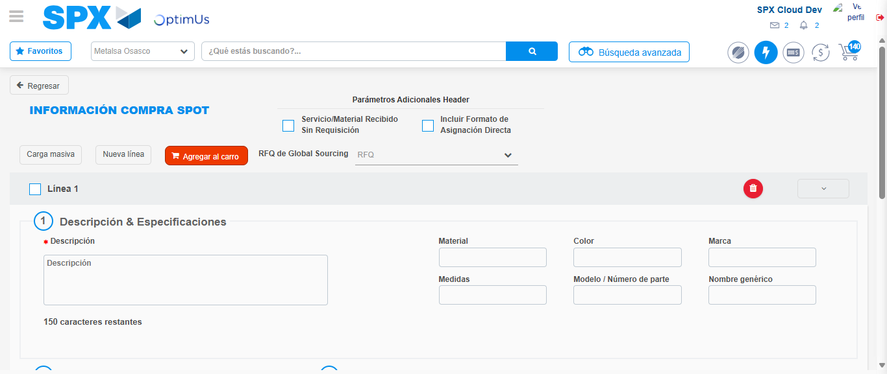Image file-name: QC_Testing-tc002_SPX_Dev5_Crear_Requisicion_Spot_Con_FAD_Tipo_Cobro_CC-1789485137021

Step 8 - Return to Main Page SPX : Return to Main Page SPX
Image file-name: QC_Testing-tc002_SPX_Dev5_Crear_Requisicion_Spot_Con_FAD_Tipo_Cobro_CC-1789485062456

Image file-name: QC_Testing-tc002_SPX_Dev5_Crear_Requisicion_Spot_Con_FAD_Tipo_Cobro_CC-1789485063144

Image file-name: QC_Testing-tc002_SPX_Dev5_Crear_Requisicion_Spot_Con_FAD_Tipo_Cobro_CC-1789485074724

Image file-name: QC_Testing-tc002_SPX_Dev5_Crear_Requisicion_Spot_Con_FAD_Tipo_Cobro_CC-1789485139307

Image file-name: QC_Testing-tc002_SPX_Dev5_Crear_Requisicion_Spot_Con_FAD_Tipo_Cobro_CC-1789485139502

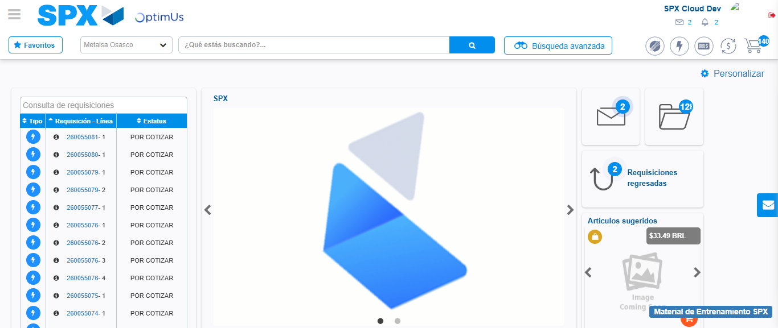Image file-name: QC_Testing-tc002_SPX_Dev5_Crear_Requisicion_Spot_Con_FAD_Tipo_Cobro_CC-1789485160766

Step 9 - Log Out : Log Out SPX
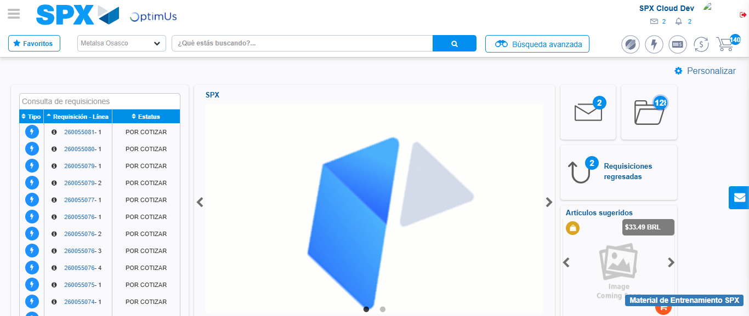Image file-name: QC_Testing-tc002_SPX_Dev5_Crear_Requisicion_Spot_Con_FAD_Tipo_Cobro_CC-1789485161186

